How to Make Steak Tartare
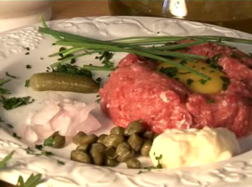
A traditional and exquisite starter dish suitable for dinner parties and special occasion meals. The beef used must be fresh, of top quality, and ground just as you're about to prepare this recipe.
Serves 4
Preparation time: 20 minutes

edit Ingredients
- 30 ounces (800 grams) high quality minced beef - filet mignon, top sirloin, or lean raw fillet steak;^{[1]} this must be freshly ground by you just prior to making this recipe
- 1 medium onion (chopped)
- 4 tablespoons capers
- 4 gherkins
- 4 tablespoons parsley (chopped)
- 4 tablespoons mayonnaise
- 4 egg yolks (optional)
- Salt and pepper
- 2 tablespoons olive oil

edit Steps
- 1

Prepare the meat. Place it into a suitably sized bowl.
Ads by Google

Restaurant Recipe Secrets
300+ Restaurant Recipes Revealed Enjoy Cooking Your Favs at Home!
www.onlinerecipesecrets.net
- 2
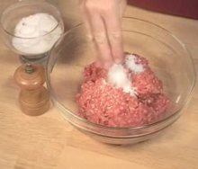
Add the salt, pepper, and olive oil into the bowl.
- 3
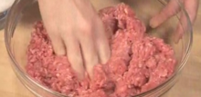
Use your hands to mix everything together well.
- 4

Take about a quarter pound (200 grams) of the seasoned meat and create a ball with it. Use both of your hands to shape the ball.
- 5

Place it on a serving plate. Press it down lightly with your palm to flatten it.
- 6

Repeat the process with three other servings, until you have a pressed ball of minced steak on each plate.
- 7
Add the egg yolks. This step is optional, but if you want yolks included, here is how to add them:
  - 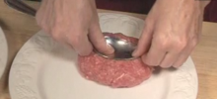
Use the back of a tablespoon to press down on the meat. Make a small indent in the center of the meat.
  - 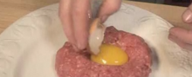
Break the eggs one at a time and place an egg yolk in the indent.
  - 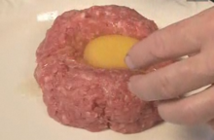
Repeat for all the meat.
- 8
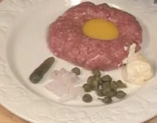
Add the garnishes. Add some mayonnaise, capers, and onions to each plate.
  - 
Spread some chopped parsley on the dish.
- 9
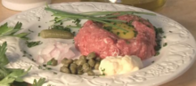
Serve. Serve immediately after making.

